CHAPTER THREE
METHODOLOGY
3.1 Introduction
This chapter presents the methodology adopted for the design and implementation of the weekly sales prediction system. The methodology integrates data engineering, data warehousing, machine learning, and business intelligence techniques to develop an intelligent system capable of predicting future weekly sales. The methodology ensures that raw transactional data is transformed into structured, meaningful, and predictive information. The process includes data extraction, data cleaning, transformation, warehouse design, feature engineering, machine learning model development, evaluation, and dashboard integration. This structured methodology ensures reliability, scalability, and accuracy of the prediction system.

3.2 Research Design
This research adopts an experimental and system development approach. The experimental approach allows different machine learning models to be trained and evaluated to determine the best-performing model. The system development approach involves building a complete pipeline consisting of ETL, data warehouse, predictive model, and dashboard visualization. This approach ensures the system can operate as a real-world business intelligence and predictive analytics solution.

3.3 Data Source and Collection
The dataset used in this research is the Online Retail dataset containing transactional records of an online retail store. The dataset contains attributes including Invoice Number, Product Code, Description, Quantity, Invoice Date, Unit Price, Customer ID, and Country. These attributes provide sufficient information to analyze sales trends, customer behavior, and product performance. The dataset represents real-world retail operations and provides a suitable foundation for predictive modeling.

3.4 ETL Process within a Business Intelligence Framework
The Extract, Transform, and Load (ETL) process represents a core component of the business intelligence framework adopted in this study. ETL provides the structured pathway through which raw transactional records from the Online Retail dataset are converted into analytically useful and decision-supportive information(Kimball & Ross, 2013). This aligns with standard BI principles, which emphasize systematic data collection, organization, and transformation as prerequisites for meaningful analysis and insight generation.(Tamang et al., 2021)
During the Extract phase, raw data is retrieved from the source dataset and imported into the Python environment using the Pandas library. This stage ensures that transactional records: including invoice details, product attributes, quantities, prices, and customer identifiers, are made accessible for subsequent processing.
The Transform phase encompasses several data preparation tasks that are essential for both business intelligence and predictive modeling. These include the removal of missing values, duplicate entries, and invalid or inconsistent records, as well as the correction of data types to ensure structural integrity. Additional derived variables, such as Revenue (computed as Quantity × Unit Price), are generated to enrich the analytical depth of the dataset. This transformation process not only enhances data quality but also enables the identification of trends, relationships, and patterns (central objectives of BI analytics).
The transformational component also implicitly incorporates BI-related activities such as data mining and data interpretation. Data mining techniques facilitate the extraction of previously hidden patterns and insights from the cleaned dataset, while interpretation ensures that these findings are contextualized in relation to real-world business operations(Tamang et al., 2021). Together, these functions enable the dataset to serve not merely as a record of past transactions but as a foundation for meaningful insight generation and predictive modeling.
In the Load phase, the cleaned and enriched data is organized into structured tables and stored in CSV format. These tables serve as the foundation for downstream processes including data warehousing, machine learning model training, and dashboard visualization. By completing the ETL cycle, the methodology ensures that raw data is systematically converted into reliable, interpretable, and analysis-ready information, consistent with the principles and objectives of business intelligence systems(Kimball & Ross, 2013).

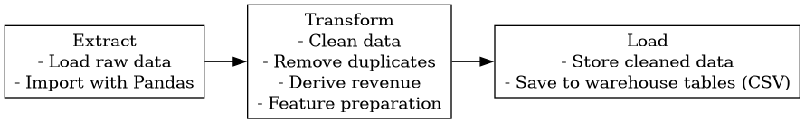
Fig 3.4.1 illustrates the ETL workflow used in this study

3.5 Data Warehouse Design
The data warehouse for this study was designed using a fact‑based star schema to support efficient analytical processing and predictive modeling. The schema organizes the cleaned and transformed dataset into a central fact table surrounded by dimension tables that provide contextual attributes.(Kimball & Ross, 2013) This structure enhances query performance, reduces redundancy, and aligns with established data warehousing principles used in business intelligence systems.
The central FactWeeklySales table stores aggregated weekly sales metrics, including Total Weekly Sales, Transaction Count, Customer Count, Quantity Sold, and the number of Unique Products Sold. Additional derived measures such as Average Order Value and Average Quantity per Transaction were included to enrich the analytical depth of the warehouse and facilitate more reliable model training.
Surrounding the fact table are dimension tables that provide descriptive attributes required for analysis. The Date Dimension captures temporal attributes such as week, month, quarter, and year, enabling time‑series‑based trend analysis. The Product Dimension stores product‑level attributes including product identifiers, descriptions, and unit prices, while the Customer Dimension captures customer‑related information such as customer identifiers and country of origin. These dimensions support flexible analytical queries and enable the machine learning models to incorporate diverse contextual factors.
Overall, the data warehouse schema provides a structured, scalable, and analysis‑ready foundation that supports both traditional BI reporting and advanced predictive analytics.(Kimball & Ross, 2013)

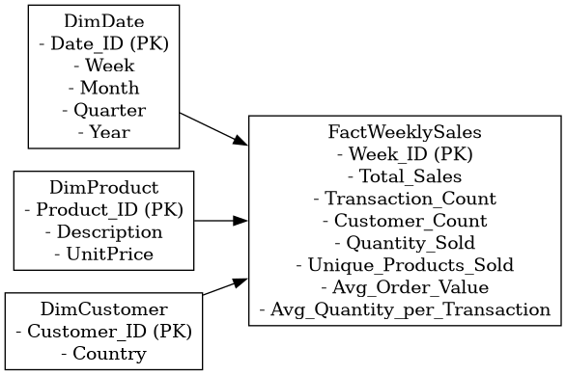
Fig 3.5.1 Data Warehouse Schema

3.6 Feature Engineering
Once the dataset has been fully cleaned and prepared, it must be transformed into a set of features that the machine learning models can effectively utilize. This transformation may involve deriving additional variables from the existing dataset or restructuring the data into formats that better represent underlying patterns relevant to prediction.(Suryawanshi et al., 2024) Feature engineering is therefore essential in converting raw structured data into meaningful representations that enhance model performance.
Given the time-series nature of weekly sales forecasting, several features were engineered to capture temporal dependencies and sales dynamics. Lag-based features were generated to represent historical sales values from previous weeks. For example, Lag_1 reflects sales from the most recent preceding week, while Lag_2 and Lag_3 correspond to sales two and three weeks prior, respectively. These features enable the model to learn sequential patterns and short-term fluctuations in demand.
To capture broader trends, rolling statistical features were also constructed. Rolling means were calculated by averaging sales across a specified number of previous weeks, providing a smoothed representation of medium‑term sales behavior. The rolling mean for a window of N weeks is expressed as:
$${Rolling Mean}_{N}=\frac{1}{N}\sum_{i=1}^{N}{{Sales}_{t-i}}$$
These features help the model recognize seasonal tendencies, momentum effects, and cyclical variations that single-week values may not adequately reflect. Other rolling statistics, such as rolling minimums, maximums, and standard deviations, may also be derived to characterize volatility, though only the most relevant features were retained to avoid overfitting.
Through this process of feature construction and transformation, the dataset is reshaped into a more expressive and informative form. The engineered features provide the machine learning algorithms with richer contextual signals, ultimately improving the accuracy and reliability of weekly sales predictions.

3.7 Machine Learning Model Development
After the feature engineering stage, an appropriate machine learning algorithm must be selected to build the predictive model.(Suryawanshi et al., 2024) Several algorithms are suitable for sales forecasting, each with different strengths depending on the structure and complexity of the data. Once the algorithm is chosen, the model is trained using the prepared dataset.(Suryawanshi et al., 2024) During training, the engineered features are supplied to the algorithm, enabling it to learn the relationship between these inputs and the corresponding weekly sales values.
In this study, three algorithms were implemented:
- Linear Regression, which models the relationship between features and sales through a linear function.(Pedregosa et al., n.d.)
- Random Forest, an ensemble‑based method that improves prediction stability by combining multiple decision trees.(Breiman, 2001)
- XGBoost, a gradient‑boosting technique optimized for high predictive accuracy and efficient learning.(Chen & Guestrin, 2016)
These models were selected because they are widely used in regression and time‑series forecasting tasks and provide a suitable balance between interpretability and predictive performance.

3.8 Model Training Procedure
The dataset was split into training and testing sets using an 80:20 ratio, with the split performed chronologically to maintain the natural order of the time-series data and prevent leakage. Each selected algorithm was then trained on the training set, where the engineered features were used as inputs and the weekly sales values served as targets. This allowed the models to learn the relationships between the features and the sales outcomes before being evaluated on unseen data.
.
3.9 Model Evaluation Metrics
The performance of each model was assessed using three standard regression metrics: Mean Absolute Error (MAE), Root Mean Squared Error (RMSE), and R-squared (R²). MAE measures the average magnitude of prediction errors, while RMSE penalizes larger errors more heavily and provides an indication of overall prediction accuracy. R² evaluates the proportion of variance in the sales data explained by the model. Together, these metrics offer a balanced assessment of error magnitude, stability, and explanatory power.

3.10 Dashboard Integration
The predictions generated by the trained machine learning models were exported into a structured dataset and integrated into a Streamlit-based dashboard. The dashboard visualizes both actual and predicted weekly sales, enabling side-by-side comparison of model outputs. This visualization supports intuitive interpretation of forecasting performance and provides a practical interface for data-driven decision-making.

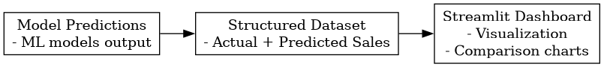
Fig 3.10. 1 Dashboard Workflow

3.11 Tools and Technologies
The system was implemented using the Python programming language, selected for its robust ecosystem supporting data processing, machine learning, and visualization tasks. The Pandas library facilitated data cleaning and structuring, while Scikit-learn provided the core functions for model development and performance assessment. XGBoost was employed to implement gradient-boosted decision tree models, and Matplotlib was used to create exploratory and analytical visualizations. For deployment and interactive presentation of results, the Streamlit framework was utilized to develop a dashboard capable of displaying actual and predicted sales in real time. All components of the system were developed and managed within the Visual Studio Code environment, which served as the integrated development platform.

3.12 Summary
This chapter presented the methodology used to develop the weekly sales prediction system, detailing each stage from data preparation to model deployment. The approach integrated business intelligence principles, an ETL process, and a star-schema data warehouse to ensure a structured and reliable analytical foundation. Feature engineering techniques were applied to capture temporal sales patterns, followed by the development and training of multiple machine learning models using the prepared dataset. Model performance was evaluated using standard regression metrics, and the final predictions were incorporated into an interactive Streamlit dashboard to support visualization and decision-making. Together, these methodological components establish a coherent framework for generating accurate and actionable sales forecasts.

Breiman, L. (2001). Random Forests. Machine Learning, 45(1), 5–32. https://doi.org/10.1023/A:1010933404324
Chen, T., & Guestrin, C. (2016). XGBoost: A Scalable Tree Boosting System. Proceedings of the 22nd ACM SIGKDD International Conference on Knowledge Discovery and Data Mining, 785–794. https://doi.org/10.1145/2939672.2939785
Kimball, R., & Ross, M. (2013). The data warehouse toolkit: The definitive guide to dimensional modeling (Third edition). John Wiley & Sons, Inc.
Pedregosa, F., Pedregosa, F., Varoquaux, G., Varoquaux, G., Org, N., Gramfort, A., Gramfort, A., Michel, V., Michel, V., Fr, L., Thirion, B., Thirion, B., Grisel, O., Grisel, O., Blondel, M., Prettenhofer, P., Prettenhofer, P., Weiss, R., Dubourg, V., … Cournapeau, D. (n.d.). Scikit-learn: Machine Learning in Python. MACHINE LEARNING IN PYTHON.
Suryawanshi, V., Venkatesan, M., Chate, S., Amane, S., Bhondekar, A., & Mulani, F. (2024). Sales Forecast Prediction Using Machine Learning. 2024 Intelligent Systems and Machine Learning Conference (ISML), 745–750. https://doi.org/10.1109/ISML60050.2024.11007449
Tamang, M. D., Kumar Shukla, V., Anwar, S., & Punhani, R. (2021). Improving Business Intelligence through Machine Learning Algorithms. 2021 2nd International Conference on Intelligent Engineering and Management (ICIEM), 63–68. https://doi.org/10.1109/ICIEM51511.2021.9445344

